The diagram below shows how chewing gum is made.
Summarise the information by selecting and reporting the main features, and make comparisons where relevant. (Nguồn: Cambridge Vocabulary for IELTS – Paulin Cullen)

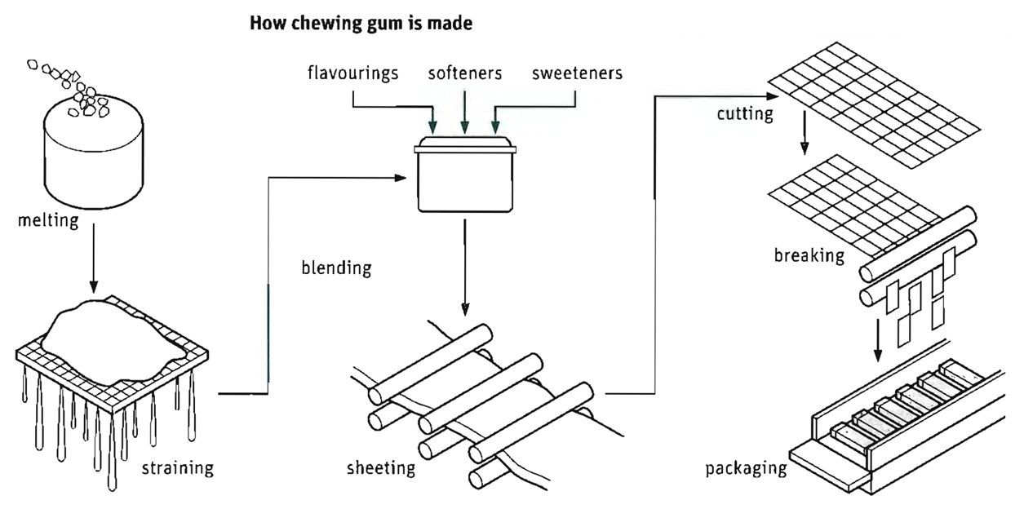

Bài làm:

